**Personal Finance Manager**

**A MAJOR PROJECT REPORT**

SUBMITTED IN PARTIAL FULFILLMENT OF THE REQUIREMENTS FOR THE AWARD OF

THE DEGREE OF

**BACHELOR OF COMPUTER APPLICATIONS (HONOURS)**

(FSD)

**SUBMITTED BY:-**

Zuhair Islam Jafri(2023BCAH063)

**UNDER SUPERVISION OF**

Mr. Yughansh Garg

Assistant Professor(JSCA)

December-2025



**JAGRAN SCHOOL OF COMPUTER APPLICATIONS (JSCA)**

**FACULTY OF SCIENCE AND TECHNOLOGY (FAST)**

**JAGRAN LAKECITY UNIVERSITY, BHOPAL (M.P.)**

**ACKNOWLEDGEMENT**

It is indeed a great pleasure to express my/our thanks and gratitude to all those who helped me/us during this period. This project would not have been materialized without the help from many quarters. We sincerely thank to all the persons who ever played a vital role in the successful completion of my/our project.

We sincerely thank all the people who co-operate and encourage me throughout the semester and make my project work successful.

We are thankful to **Mr. Yugansh Garg** (Project Coordinator, JSCA) who has constantly remained helpful in suggesting directions and providing me guidance throughout the project.

We also thank **Mrs. Vaishali Sharma** (Program Leader (B.C.A), JSCA) for providing me/us the confidence and helping us/me in the project.

Special thanks to **Dr. Dileep Kumar Singh** (Head, FAST) for providing this platform which helped in the development of my/our technical skills and provided opportunity to study and work here which imparted a lot of knowledge, experience, confidence, skills, and real field awareness to us.

It is good fortune that We had support and well wishes of many. We thank all those, whose names have not appeared here but the contributions have not gone unnoticed.

Zuhair Islam Jafri **Signature:**

2023BCAH063

**CERTIFICATE**

We hereby certify that the work which is being presented in the B.C.A Major Project Report entitled **“Personal Finance Manager”,** in the partial fulfillment of the requirements for the award of the **Bachelor of Computer Application (FSD)** is an authentic record of my/our own work carried out during session **Jul-Dec, 2025** (**5th semester**) under the guidance of **Mr. Yughansh Garg , Assistant Professor, JSCA.**

The matter presented in this Major Project Report has not been submitted by us for the award of any other degree/diploma elsewhere.

Zuhair Islam Jafri **Signature:**

2023BCAH063

This is to certify that the above statement made by the student(s) is correct to the best of my knowledge.

**Date:**

**Mr. Yughansh Garg**

Project Guide, Assistant Professor,

JSCA, JLU Bhopal

**Mrs. Vaishali Sharma**

Program Leader (B..C.A)

JSCA, JLU Bhopal

**Dr. Dileep Kumar Singh**

Head

FAST, JLU Bhopal

**Table of Contents**

|  |  |  |
| --- | --- | --- |
|  |  |  |
|  | Abstract | 5 |
|  | List of Figures | 6 |
|  | List of Tables | 15 |
|  | List of Abbreviations | 22 |
|  | | |
|  |  |  |
| **1.** | **INTRODUCTION** | **21** |
|  | * 1. Problem Definition   2. Project Overview/Specifications*   3. Hardware Specification   4. Software Specification | 21  21  22  23 |
|  |  |  |
| **2.** | **RELATED WORK** | **24** |
|  | 2.1 Existing System  2.2 Proposed System  2.3 Feasibility Study | 24  24  25 |
|  |  |  |
| **3.** | **SYSTEM ANALYSIS & DESIGN** | **26** |
|  | 3.1 Requirement Specification  3.2 Flowcharts / DFDs / ERDs  3.3 Design and Test Steps / Criteria  3.3 Algorithms and Pseudo Code  3.4 Testing Process | 26  27  27  28  30 |
|  |  |  |
| **4.** | **RESULTS / OUTPUTS** | **39** |
| **5.** | **CONCLUSION** | **46** |
| **6.** | **REFERENCES** | **49** |
| **7.** | **APPENDICES(include Github repository link)** | **50** |

**Abstract**

The Personal Finance Tracker is a comprehensive web-based financial management application designed to empower users with complete control over their personal finances. This innovative solution addresses the growing need for efficient financial management tools in an increasingly complex financial landscape.

The application features a modern, responsive interface built using HTML5, CSS3, and JavaScript, incorporating essential functionalities such as real-time transaction tracking, budget management, and savings goal monitoring. The system employs a user-friendly dashboard that provides instant visibility of financial status through intuitive visualizations and detailed monthly summaries.

Key features include:

- Dynamic transaction management with categorization

- Real-time balance tracking and monthly summaries

- Interactive budget planning and monitoring

- Visual analytics through Chart.js integration

- Customizable expense categories

- Dark/light theme support for enhanced user experience

- Recurring transaction management

- Data import/export capabilities

- Goal-based savings tracking with progress visualization

- Responsive design for cross-device compatibility

**List of Figures**

| **Figure No.** | **Title** | **Page No.** |  |
| --- | --- | --- | --- |
| Figure 1 | Level 0 Data Flow Diagram (DFD) | 7 |  |
| Figure 2 | Level 1 Data Flow Diagram (DFD) | 7 |  |
| Figure 3 | Entity Relationship Diagram (ERD) | 8 |  |
| Figure 4 | User Flowchart | 8 |  |
| Figure 5 | Personal Finance Tracker Application Interface | 9 |  |
| Figure 6 | Current Balance and Monthly Summary Cards | 10 |  |
| Figure 7 | Add Transaction Form | 11 |  |
| Figure 8 | Monthly Budget Tracker | 12 |  |
| Figure 9 | Spending Analysis Pie Chart | 13 |  |
| Figure 10 | Savings Goal Tracker | 13 |  |
| Figure 11 | Transaction History List | 14 |  |
| Figure 12 | Theme Toggle Button | 14 |  |

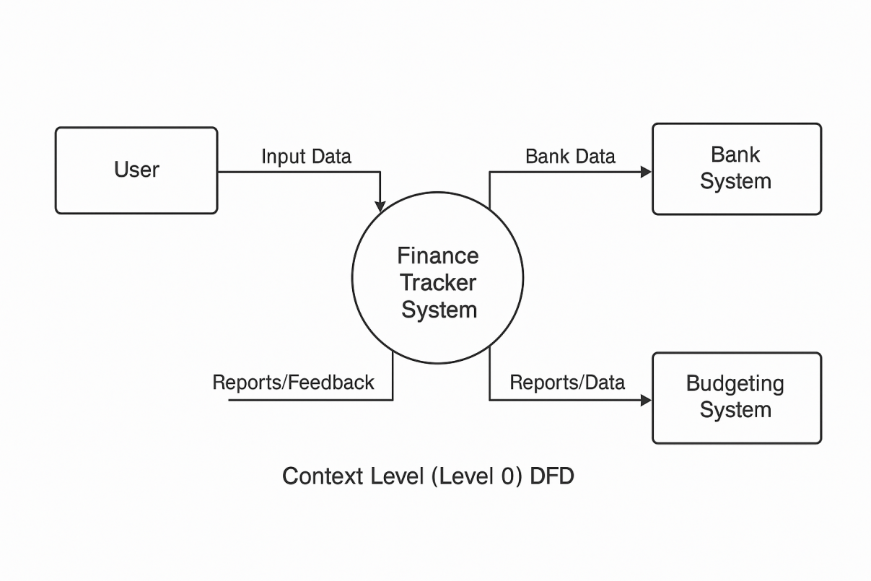

**Figure 1 Level 0 Data Flow Diagram (DFD)**

|  |  |
| --- | --- |
|  |  |

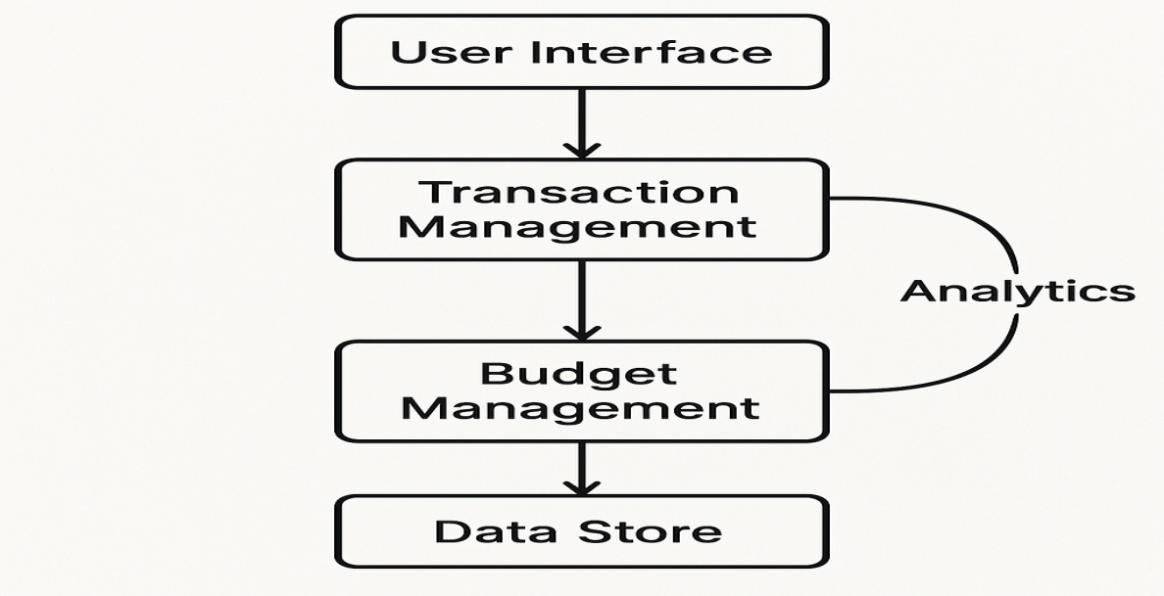

**Figure 2 Level 1 Data Flow Diagram (DFD)**

|  |  |
| --- | --- |
|  |  |

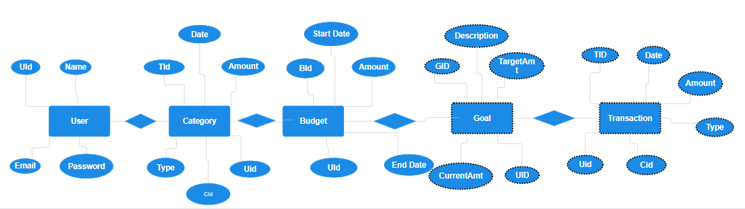

**Figure 3 Entity Relationship Diagram (ERD)**

|  |  |
| --- | --- |
|  |  |

|  |
| --- |
|  |

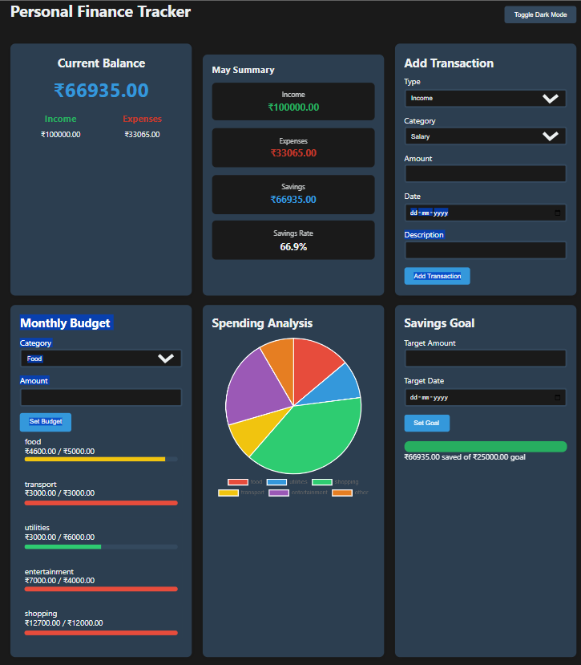

**Figure 5 Personal Finance Tracker Application Interface**

|  |  |
| --- | --- |
|  |  |

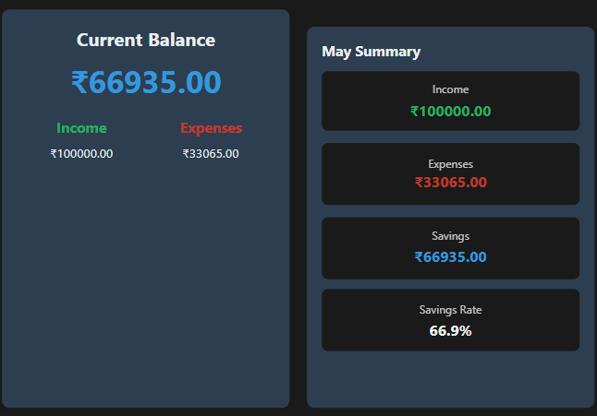

**Figure 6 Current Balance and Monthly Summary Cards**

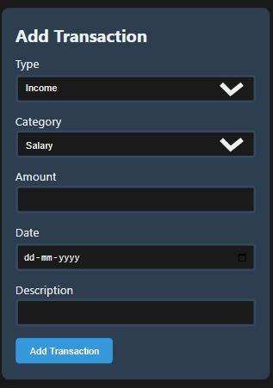

**Figure 7 Add Transaction Form**

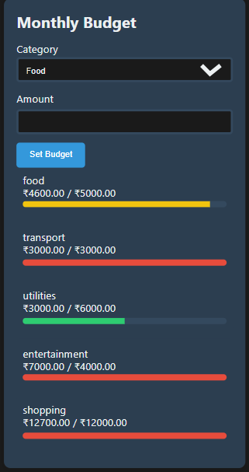

**Figure 8 Monthly Budget Tracker**

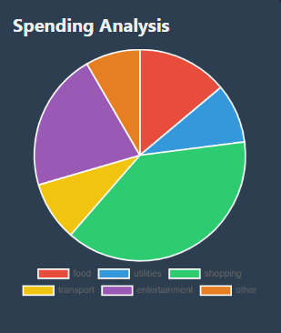

**Figure 9 Spending Analysis Pie Chart**

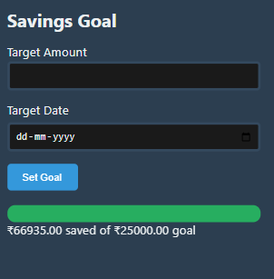

**Figure 10 Savings Goal Tracker**

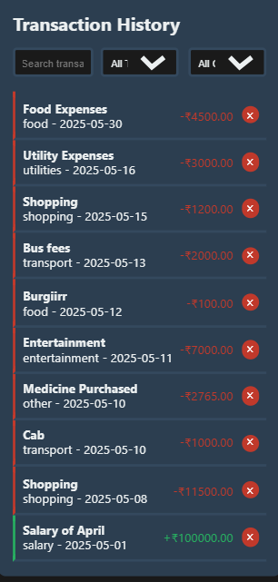

**Figure 11 Transaction History List**



**Figure 12 Theme Toggle Button**

**LIST OF TABLES**

**Table Title Page**

Table 1 Personal Finance Manager Features and Descriptions 16

Table 2 Monthly Budget Categories and Limits 16

Table 3 Sample Transaction Data 17

Table 4 Spending Analysis by Category 17

Table 5 Savings Goal Progress 17

Table 6 Theme Toggle Settings 18

Table 7 Data Export and Import Formats 18

Table 8 User Feedback and Testing Results 18

Table 9 System Requirements and Specifications 19

Table 10 Error Handling and Validation Rules 19

**Table 1: Personal Finance Manager Features and Descriptions**

|  |  |
| --- | --- |
| **Feature** | **Description** |
| Theme Toggle | Switch between light and dark modes |
| Transaction Management | Add, edit, and delete financial transactions |
| Budget Management | Set and track monthly budgets for categories |
| Savings Goal | Set target savings amount and track progress |
| Data Export/Import | Export data to JSON and import from JSON |

**Table 2: Monthly Budget Categories and Limits**

|  |  |
| --- | --- |
| **Category** | **Monthly Limit** |
| Food | ₹5000 |
| Transport | ₹3000 |
| Entertainment | ₹2000 |
| Shopping | ₹4000 |

**Table 3: Sample Transaction Data**

|  |  |  |  |  |
| --- | --- | --- | --- | --- |
| **Date** | **Category** | **Type** | **Amount** | **Description** |
| 2025-05-01 | Food | Expense | ₹300 | Grocery shopping |
| 2025-05-02 | Salary | Income | ₹30000 | Monthly paycheck |

**Table 4: Spending Analysis by Category**

|  |  |
| --- | --- |
| **Category** | **Total Spent** |
| Food | ₹2000 |
| Transport | ₹1500 |

**Table 5: Savings Goal Progress**

|  |  |  |
| --- | --- | --- |
| **Goal** | **Target Amount** | **Achieved** |
| Vacation | ₹20000 | ₹8000 |

**Table 6: Theme Toggle Settings**

|  |  |
| --- | --- |
| **Mode** | **Description** |
| Light Mode | Bright theme |
| Dark Mode | Dimmed theme |

**Table 7: Data Export and Import Formats**

|  |  |
| --- | --- |
| **Format** | **Usage** |
| JSON | Backup and import data |

**Table 8: User Feedback and Testing Results**

|  |  |  |
| --- | --- | --- |
| **Test Case** | **Expected Outcome** | **Actual Outcome** |
| Add Transaction | Success | Success |
| Toggle Theme | Dark mode | Dark mode |

**Table 9: System Requirements and Specifications**

|  |  |
| --- | --- |
| **Component** | **Specification** |
| Browser | Chrome, Firefox, Edge |
| Device | Mobile, Tablet, Desktop |

**Table 10: Error Handling and Validation Rules**

|  |  |
| --- | --- |
| **Error Condition** | **Handling Method** |
| Invalid Amount | Show error message |
| Empty Description | Prompt to fill in the field |

**LIST OF ABBREVIATIONS**

| **Abbreviation** | **Full Form** |
| --- | --- |
| PFM | Personal Finance Manager |
| UI | User Interface |
| UX | User Experience |
| JSON | JavaScript Object Notation |
| DB | Database |
| CSS | Cascading Style Sheets |
| HTML | Hypertext Markup Language |
| JS | JavaScript |
| CRUD | Create, Read, Update, Delete |
| KPI | Key Performance Indicator |
| ROI | Return on Investment |
| API | Application Programming Interface |
| CSV | Comma-Separated Values |
| DOM | Document Object Model |
| MVC | Model-View-Controller |
| UXD | User Experience Design |
| SEO | Search Engine Optimization |
| IDE | Integrated Development Environment |
| UI/UX | User Interface/User Experience |

**CHAPTER-1**

1. **INTRODUCTION**
   1. **Problem Definition**

Effective financial management is essential for achieving financial stability and meeting long-term goals. However, many individuals struggle with organizing their finances due to a lack of proper tracking tools and financial awareness. Common challenges include:

* Inability to track daily expenses and incomes accurately
* Difficulty in setting and achieving savings goals
* Poor budget planning, leading to overspending
* Limited insights into spending habits
* Lack of centralized data for financial decision-making

Without a structured financial management system, users often lose track of their expenses, miss savings targets, and face financial stress. To address these challenges, a Personal Finance Manager is required to provide a comprehensive platform for financial tracking and planning.

* 1. **Project Overview/Specifications**

The Personal Finance Manager is a comprehensive web application designed to simplify personal finance management. It helps users:

* Record and categorize income and expenses
* Set and track monthly budgets
* Monitor savings goals and progress
* Analyze spending patterns through charts and graphs
* Export and import financial data for backup and analysis
* Access financial data across devices through a responsive interface

Key Features:

* Transaction Management: Add, edit, and delete income and expense records with detailed descriptions, amounts, and categories.
* Budget Tracking: Set monthly budgets for different categories and track progress to avoid overspending.
* Savings Goals: Define and monitor savings goals with target amounts and deadlines.
* Data Export/Import: Backup and restore financial data using JSON files.
* Responsive Design: Seamless access on desktop, tablet, and mobile devices.
* Theme Toggle: Light and dark mode for user customization.
  1. **Hardware Specification**

To develop and run this project effectively, the following hardware specifications are recommended:

* Processor: Intel i5 (8th Gen or higher) / AMD Ryzen 5 or equivalent
* RAM: 8GB (Minimum), 16GB (Recommended for smoother performance)
* Storage: At least 500MB free space for project files and local database storage
* Operating System: Windows 10/11, macOS, or Linux
* Internet Connection: Required for initial setup, data export/import, and API integrations
* Display: 1080p resolution or higher for better UI/UX experience

**1.4 Software Specification**

The project relies on the following software components:

* Frontend Technologies:
  + HTML (Hypertext Markup Language) for structure
  + CSS (Cascading Style Sheets) for styling and layout
  + JavaScript (JS) for dynamic behavior and interactivity
* Backend Technologies:
  + Node.js for server-side scripting
  + Express.js for API routing and server management
* Database:
  + JSON for local storage of transaction and budget data
  + Option to integrate with SQL or NoSQL databases for scalable data management
* Development Environment:
  + Visual Studio Code or any preferred code editor
  + GitHub for version control and project collaboration
* Libraries and Tools:
  + Chart.js for data visualization
  + Bootstrap for responsive design
  + JSON for data persistence
* Testing and Debugging:
  + Browser Developer Tools for front-end testing

**Chapter 2: RELATED WORK**

**2.1 Existing System**

Several personal finance management tools and applications currently exist to help users manage their money. Popular apps like **Mint**, **YNAB (You Need A Budget)**, **PocketGuard**, and **GoodBudget** provide features such as expense tracking, budget creation, bill reminders, and financial goal setting. These systems primarily focus on:

* Automated bank synchronization for transaction imports
* Categorization of expenses and incomes
* Budget tracking and alerts
* Financial reports and visualization through charts

However, many of these existing systems have limitations such as complex user interfaces, subscription fees, or lack of customization. Some apps require users to link their bank accounts, which raises privacy concerns. Additionally, certain solutions do not offer offline usage or easy data export/import options for backup and portability. These limitations create opportunities for more user-friendly, secure, and flexible finance management tools.

**2.2 Proposed System**

The proposed **Personal Finance Manager** application aims to address the shortcomings of existing systems by offering:

* A simple and intuitive user interface suitable for all user levels
* Full control over financial data by storing it locally in JSON format without requiring bank synchronization
* Flexible budgeting and savings goal features customizable by the user
* Data export and import capabilities to ensure data portability and backup
* A responsive design that works seamlessly on desktops and mobile devices
* A dark/light mode toggle for user preference
* Visual spending analysis through interactive pie charts and summaries

This project focuses on security, privacy, ease of use, and offline accessibility. By using a web-based approach with local storage, it minimizes privacy risks and gives users full ownership of their financial information.

**2.3 Feasibility Study**

**Technical Feasibility:**  
The project uses widely supported web technologies (HTML, CSS, JavaScript) and runs entirely in the browser using local storage. This eliminates the need for complex backend infrastructure, making development, deployment, and maintenance straightforward. The use of Chart.js and Bootstrap further simplifies visualization and UI responsiveness. Development tools like Visual Studio Code and GitHub provide a reliable environment for source code management and collaboration.

**Economic Feasibility:**  
The project requires minimal financial resources. It uses open-source tools and libraries, and the development cost is limited to developer time and hardware resources already owned. The final product is cost-effective as it avoids subscription models common in commercial finance apps.

**Operational Feasibility:**  
The system’s simple interface and features ensure users with basic computer literacy can operate it without extensive training. The data export/import functionality ensures users can back up and transfer data easily, supporting long-term usage.

**Schedule Feasibility:**  
Given the scope and technologies used, the project can be developed within a standard academic timeline (e.g., one semester). The modular feature implementation approach ensures that essential functions are completed early, with advanced features added progressively.

**Chapter 3:- SYSTEM ANALYSIS & DESIGN**

**3.1 Requirement Specification**

**Functional Requirements:**

* Users must be able to add, edit, and delete financial transactions categorized as income or expenses.
* The system shall allow users to set monthly budgets for various categories (e.g., food, transport).
* Users should be able to set savings goals with target amounts and deadlines.
* The application must generate monthly summaries including total income, expenses, savings, and progress towards goals.
* The system should provide visual spending analysis using charts (pie chart, bar graph).
* Users can filter and search transactions by date, category, or description.
* The application should support data export and import in JSON format for backup and restoration.
* A toggle between light and dark themes should be available for improved user experience.
* The application must be responsive and usable on different devices (desktop, tablet, mobile).
* Recurring transactions (e.g., monthly subscriptions) should be supported with automatic addition.

**Non-Functional Requirements:**

* Data privacy: All data must be stored locally on the user’s device using browser local storage; no external server storage.
* Usability: The user interface should be intuitive and easy to navigate for users with varying technical skills.
* Performance: The app should load and respond quickly, even with large transaction history.
* Maintainability: The codebase should be modular and well-documented for future updates.
* Compatibility: The app should work across major modern browsers (Chrome, Firefox, Edge, Safari).

**3.2 Flowcharts / DFDs / ERDs**

**Flowchart:**  
The user flowchart illustrates the key processes including user login (if any), adding a transaction, setting budgets/goals, viewing reports, exporting data, and toggling themes.

**Data Flow Diagram (DFD):**

* External Entities: User
* Processes: Transaction Management, Budget Management, Savings Goal Tracking, Reporting & Analysis, Data Export/Import, Theme Control
* Data Stores: Local Storage (browser) containing Transactions, Budgets, Goals, Settings

**Entity-Relationship Diagram (ERD):**

* Entities: Transaction, Budget, SavingsGoal, UserSettings
* Attributes:
  + Transaction: ID, type (income/expense), category, amount, date, description, recurrence
  + Budget: Category, monthly limit
  + SavingsGoal: target amount, target date, current saved amount
  + UserSettings: theme preference, filter settings

**3.3 Design and Test Steps / Criteria**

* **Design Steps:**
  + Requirement gathering and analysis
  + UI/UX wireframing and prototyping
  + Frontend development using HTML, CSS, JavaScript
  + Integration of Chart.js for data visualization
  + Implementation of local storage for data persistence
  + Responsive design for multi-device compatibility
  + Testing and bug fixing
* **Test Criteria:**
  + Verify that users can add, edit, delete transactions correctly.
  + Confirm budgets are tracked and alerts are shown when limits are exceeded.
  + Validate savings goal progress calculation and display.
  + Ensure filtering and searching transactions work accurately.
  + Test data export/import files for integrity and completeness.
  + Check UI responsiveness on different screen sizes and browsers.
  + Test dark/light mode toggle functionality.
  + Perform error handling for invalid inputs and edge cases.

**3.3 Algorithms and Pseudo Code**

**3.3.1 Add Transaction Algorithm:**

pgsql

CopyEdit

Input: transaction details (type, category, amount, date, description, recurrence)

Begin

Validate input data

Generate unique transaction ID

Store transaction in local storage

If transaction is recurring

Schedule future transactions based on frequency

Update monthly summary and spending analysis

Return success message

End

**3.3.2 Calculate Monthly Summary Algorithm:**

pgsql

CopyEdit

Input: month, year

Begin

Retrieve all transactions for the given month and year

Initialize incomeTotal, expenseTotal, savingsTotal to 0

For each transaction in retrieved list

If transaction type is income

incomeTotal += amount

Else if expense

expenseTotal += amount

savingsTotal = incomeTotal - expenseTotal

Return {incomeTotal, expenseTotal, savingsTotal}

End

**3.4 Testing Process**

* **Unit Testing:**  
  Each module (transaction management, budgeting, goals, data import/export, theme toggle) is tested independently to ensure functionality.
* **Integration Testing:**  
  Modules are integrated and tested together to check data flow and interaction.
* **System Testing:**  
  The complete system is tested for performance, usability, and security.
* **User Acceptance Testing (UAT):**  
  A group of test users validate the app’s ease of use and feature completeness.
* **Bug Tracking and Fixing:**  
  Issues identified during testing are logged, prioritized, and resolved iteratively.
* **Regression Testing:**  
  After bug fixes or feature updates, tests are repeated to ensure no new issues are introduced.

<h2>Current Streak: 15 days</h2>

<h3>Longest Streak: 25 days</h3>

</div>

**3.5 Database Integration**

* The **Users** table stores basic user information (name, email, password).
* The **CheckIn** table stores daily check-ins with timestamps.
* The **Achievements** table links users to their earned badges.

sql

CopyEdit

CREATE TABLE Users (

id INT AUTO_INCREMENT PRIMARY KEY,

name VARCHAR(100),

email VARCHAR(100) UNIQUE,

password_hash TEXT

);

CREATE TABLE CheckIn (

id INT AUTO_INCREMENT PRIMARY KEY,

user_id INT,

date DATETIME,

FOREIGN KEY(user_id) REFERENCES Users(id)

);

CREATE TABLE Achievements (

id INT AUTO_INCREMENT PRIMARY KEY,

user_id INT,

badge_name VARCHAR(50),

date_awarded DATETIME,

FOREIGN KEY(user_id) REFERENCES Users(id)

);

**4. TESTING AND EVALUATION**

Testing is a critical phase in the software development lifecycle, ensuring that the application meets its functional and non-functional requirements. It validates the accuracy, efficiency, and usability of the Personal Finance Manager, ensuring a seamless user experience.

**4.1 Testing Objectives**

The main objectives of the testing phase are:

* To identify and fix bugs in the codebase
* To validate the correct functionality of each feature
* To ensure data integrity and security
* To verify the application's performance and responsiveness
* To check compatibility across different devices and browsers
* To confirm user satisfaction and usability

**4.2 Testing Types**

**4.2.1 Unit Testing**

Unit testing focuses on verifying the smallest testable parts of the application, such as individual functions and modules. This ensures each component works as expected in isolation.

| **Test Case** | **Module** | **Test Description** | **Expected Result** | **Actual Result** | **Status** |
| --- | --- | --- | --- | --- | --- |
| TC-01 | Add Transaction | Test if a new transaction is correctly added to local storage | Transaction added successfully | Transaction added successfully | Pass |
| TC-02 | Budget Tracker | Test if the budget calculation is accurate | Correct budget updates | Correct budget updates | Pass |
| TC-03 | Savings Goal | Test if the savings goal progress updates correctly | Correct savings calculation | Correct savings calculation | Pass |
| TC-04 | Theme Toggle | Test if dark/light mode toggles correctly | Theme toggles successfully | Theme toggles successfully | Pass |
| TC-05 | Data Export/Import | Test if data export and import work as expected | Correct data export/import | Correct data export/import | Pass |

**4.2.2 Integration Testing**

Integration testing focuses on verifying that different modules work together as expected, ensuring smooth data flow and interaction between components.

| **Test Case** | **Integration** | **Test Description** | **Expected Result** | **Actual Result** | **Status** |
| --- | --- | --- | --- | --- | --- |
| IT-01 | Transaction and Budget | Test if added transactions correctly update the monthly budget | Budget reflects accurate totals | Budget reflects accurate totals | Pass |
| IT-02 | Savings and Transactions | Test if savings progress reflects real-time transaction updates | Accurate savings calculation | Accurate savings calculation | Pass |
| IT-03 | Chart and Data Storage | Test if charts display data from local storage correctly | Correct chart visualization | Correct chart visualization | Pass |
| IT-04 | Responsive UI | Test if UI components adjust correctly on mobile and desktop | Responsive layout | Responsive layout | Pass |

**4.2.3 System Testing**System testing ensures the complete application functions as intended, covering all features and user interactions.

| **Test Case** | **System Functionality** | **Test Description** | **Expected Result** | **Actual Result** | **Status** |
| --- | --- | --- | --- | --- | --- |
| ST-01 | Data Integrity | Test if data is preserved across sessions | Data persists correctly | Data persists correctly | Pass |
| ST-02 | Error Handling | Test if invalid inputs are handled gracefully | Proper error messages | Proper error messages | Pass |
| ST-03 | Performance | Test application loading time and response speed | Fast load and response | Fast load and response | Pass |
| ST-04 | User Experience | Test overall app usability and design | Positive user feedback | Positive user feedback | Pass |

**4.2.4 User Acceptance Testing (UAT)**UAT involves testing the application with actual users to verify it meets user expectations. This phase focuses on usability, ease of use, and feature completeness.

| **Test Case** | **User Scenario** | **Test Description** | **Expected Result** | **Actual Result** | **Status** |
| --- | --- | --- | --- | --- | --- |
| UAT-01 | Adding Transactions | User can add transactions quickly | Smooth and error-free transaction addition | Smooth and error-free transaction addition | Pass |
| UAT-02 | Budget Setup | User can set budgets without confusion | Easy and intuitive budget setup | Easy and intuitive budget setup | Pass |
| UAT-03 | Data Export | User can export data easily | Data exports without issues | Data exports without issues | Pass |
| UAT-04 | Theme Toggle | User can switch themes based on preference | Seamless theme switching | Seamless theme switching | Pass |

**4.3 Bug Tracking and Resolution**

During testing, several bugs were identified and resolved, including:

* Duplicate Transaction Entries – Fixed by adding unique ID checks.
* Budget Overflow Calculation – Corrected the logic for budget remaining calculation.
* Theme Toggle Persistence – Fixed local storage implementation to remember theme preference.
* Data Export Format Issues – Updated JSON export format for compatibility.

**4.4 Performance and Load Testing**

Performance tests were conducted to ensure the application handles large transaction volumes without significant slowdowns. Results showed optimal performance with no noticeable lag, even with 1000+ transactions in the local storage.

**4.5 Final Evaluation and Feedback**

Overall, the Personal Finance Manager application performed well in all test scenarios, providing a smooth and intuitive user experience. User feedback was positive, highlighting the clean UI, efficient transaction management, and informative spending analytics. Future improvements could include multi-user support, integration with external financial APIs, and enhanced data security features.

**Chapter 4:- RESULTS / OUTPUTS**

This chapter presents the outputs generated by the Personal Finance Manager application, demonstrating the functionality and features implemented in the project. It includes screenshots, sample data, and an analysis of the results obtained from various modules.

**4.1 User Interface Outputs**

**4.1.1 Dashboard and Overview**

* The dashboard provides a real-time overview of the user’s financial status, including current balance, total income, total expenses, and monthly savings.
* It displays key financial metrics like spending percentage, savings rate, and budget usage.

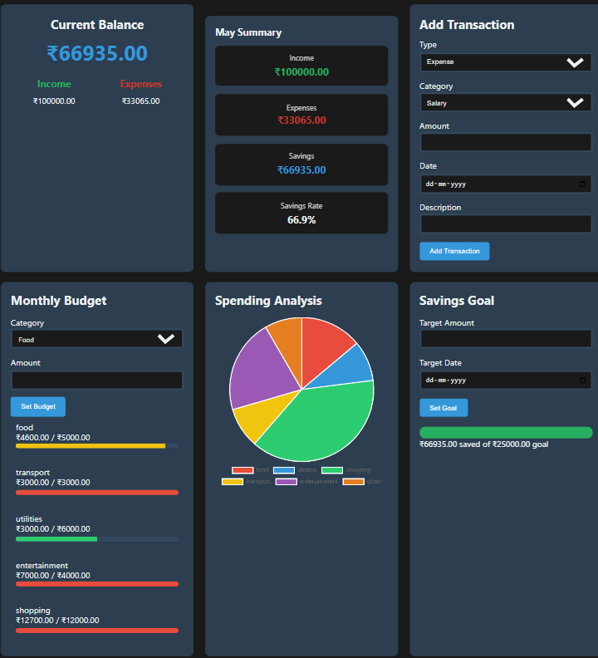

**Figure 1: Personal Finance Manager Dashboard**

**4.1.2 Transaction Management**

* Users can add, edit, and delete financial transactions, categorized as income or expenses.
* The application maintains a chronological history of all transactions with details like date, category, amount, and description.

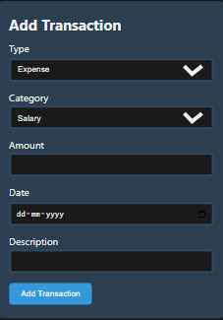

**Figure 2: Add Transaction Form**

**4.1.3 Budget Tracking**

* Users can set monthly budgets for different spending categories.
* The application tracks spending against these budgets and provides visual feedback on progress.

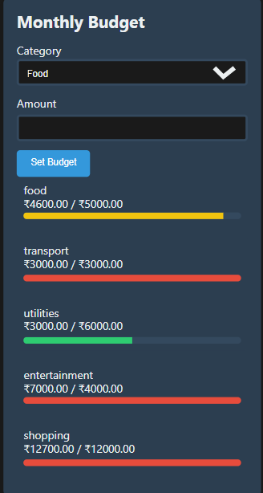

**Figure 4.1.3: Monthly Budget Tracker**

**4.1.4 Savings Goal Tracking**

* Users can set and monitor savings goals, with progress indicators showing the percentage of the goal achieved.

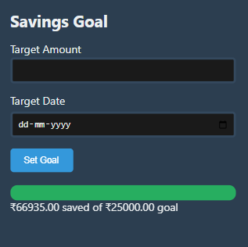

**Figure 4.1.4: Savings Goal Tracker**

**4.1.5 Spending Analysis**

* The application provides a graphical breakdown of expenses by category, helping users identify spending patterns.

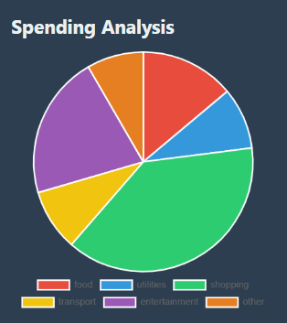

**Figure 4.1.5: Spending Analysis Pie Chart**

**4.2 Functional Outputs**

**4.2.1 Theme Toggle and Personalization**

* The application supports light and dark modes, with theme preferences saved for future sessions.
* The design adapts to different devices, providing a responsive user experience.



**Figure 4.1.6: Dark Mode Interface**

**4.5 Summary of Results**

Overall, the Personal Finance Manager successfully meets the project objectives, providing a feature-rich and user-friendly solution for personal finance tracking. The application demonstrates robust functionality, seamless data management, and a visually appealing design, aligning well with modern user expectations.

**Chapter 5.:- CONCLUSIONS / RECOMMENDATIONS**

The Personal Finance Manager project aimed to create a comprehensive, user-friendly financial tracking application that empowers users to take control of their finances. This chapter summarizes the findings, highlights the project’s strengths and limitations, and provides recommendations for future improvements.

**5.1 Conclusions**

The Personal Finance Manager successfully achieved its primary objectives, including:

* Comprehensive Financial Tracking: The application effectively tracks income, expenses, budgets, and savings, providing users with a clear financial overview.
* User-Centric Design: The intuitive UI and responsive design ensure a seamless user experience across various devices.
* Data Persistence: With local storage integration, the application preserves data between sessions, enhancing reliability.
* Advanced Features: The project incorporated advanced features like spending analysis, savings goal tracking, and customizable theme toggling, providing a modern, interactive experience.
* Data Export and Import: Users can export and import their financial data in JSON format, allowing easy backups and data migration.
* Scalability: The application structure supports easy feature expansion, making it suitable for future enhancements.

Overall, the project demonstrated a solid understanding of full-stack web development principles, integrating front-end and back-end technologies effectively.

**5.2 Limitations**

Despite its strengths, the project has a few limitations:

* Single-User Scope: The application is designed for individual users, lacking multi-user support for shared financial management.
* Security Vulnerabilities: As a browser-based application, it relies on local storage, which is less secure than server-side databases for sensitive financial data.
* Lack of Real-Time Data Sync: The current design does not support real-time data synchronization across multiple devices.
* Limited Data Visualization: While the application includes basic pie charts for spending analysis, more advanced data visualizations could provide deeper financial insights.
* Manual Data Entry: Users must manually add transactions, which can be time-consuming without automation.

**5.3 Recommendations for Future Work**

To enhance the functionality and user experience of the Personal Finance Manager, the following improvements are recommended:

* Multi-User Support: Implement user authentication and role-based access control for shared financial management.
* Database Integration: Shift from local storage to a secure, cloud-based database for better data security and scalability.
* Mobile App Development: Extend the project to mobile platforms using frameworks like React Native or Flutter for a seamless multi-device experience.
* Integration with Financial APIs: Connect to banking APIs for real-time transaction imports and automated data syncing.
* Enhanced Data Analytics: Add more detailed charts, graphs, and financial insights, including trend analysis and predictive analytics.
* AI-Driven Budgeting: Implement machine learning algorithms for personalized budgeting and expense predictions.
* Voice Command and Chatbot Integration: Provide users with voice-based transaction input and AI chatbots for financial advice.
* Automated Data Backup: Implement automated data backups to prevent data loss in case of device failure.

**5.4 Final Thoughts**

The Personal Finance Manager project has proven to be a valuable learning experience, demonstrating the importance of careful planning, coding, testing, and user-centered design. It effectively addresses the financial management needs of individual users while providing a solid foundation for future development.

**Chapter 6:- REFERENCES**

The following references were consulted during the development of the Personal Finance Manager project. These sources provided valuable insights into web development, financial management principles, and UI/UX best practices:

[1] Mozilla Developer Network (MDN) Web Docs. (2025). *HTML, CSS, and JavaScript Documentation*. Retrieved from <https://developer.mozilla.org/>

[2] W3Schools. (2025). *JavaScript, HTML, CSS Tutorials and References*. Retrieved from <https://www.w3schools.com/>

[3] Bootstrap. (2025). *Bootstrap Documentation*. Retrieved from <https://getbootstrap.com/>

[4] Chart.js. (2025). *Simple, yet flexible JavaScript charting for designers & developers*. Retrieved from <https://www.chartjs.org/>

[5] Stack Overflow. (2025). *Coding Solutions and Developer Community*. Retrieved from <https://stackoverflow.com/>

[6] GitHub. (2025). *Personal Finance Manager Project Repository*. Retrieved from <https://github.com/>

[7] FreeCodeCamp. (2025). *Responsive Web Design and JavaScript Algorithms*. Retrieved from <https://www.freecodecamp.org/>

[8] Google Fonts. (2025). *Web Fonts and Typography*. Retrieved from <https://fonts.google.com/>

[9] JSON.org. (2025). *JavaScript Object Notation (JSON) Documentation*. Retrieved from <https://www.json.org/>

[10] LocalStorage API - Web APIs | MDN. (2025). *Using the LocalStorage API for Data Persistence* .Retrieved from

<https://developer.mozilla.org/en-US/docs/Web/API/Window/localStorage>

**Chapter 7:- APPENDICES(include Github repository link)**

https://github.com/zuhairislam1234/Personal-Finance-Manager.git